For Immediate Release: September 24, 2020

NEW! Associated Electrics Logo Trucker Hats
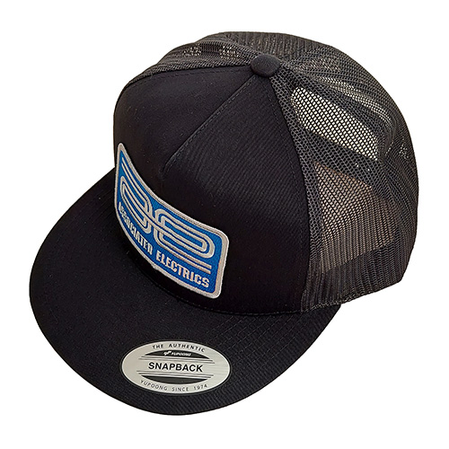  #97007 AE Logo Trucker Hat, flat bill, black | 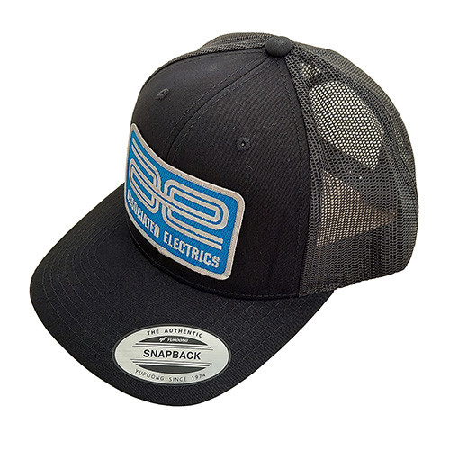  #97008 AE Logo Trucker Hat, curved bill, black

This open mesh hat keeps the sun at bay while allowing fresh air circulation and cooling. An adjustable snap strap means one-size-fits-all for any Associated Electrics (AE) fan. Available in flat bill and curved styles.

UPC | Part No. | Description | MAP | MSRP | Available
784695970076 | #97007 | AE Logo Trucker Hat, flat bill, black | $22.10 | $25.99
784695970083 | #97008 | AE Logo Trucker Hat, curved bill, black | $22.10 | $25.99

